**Task 9: Osmosis Validation**

**Science Inquiry Total Marks: 20**

**Conditions: In class validation. Students may use their hand written practical report.**

**Time for Task: 30 minutes**

**Weighting: 3%**

Students cut 6 strips of potato of approximately equal size. Each strip was placed in a solution and left for 24 hours. The strips were removed from the solutions and the length of each strip was measured. Results of the experiment are displayed in the table below.

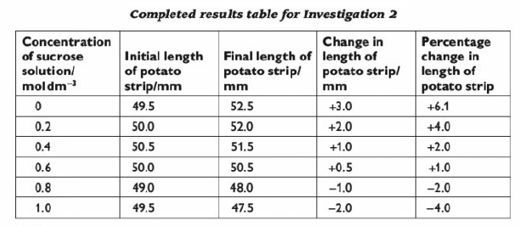

1. Draw an appropriate graph for the results (5 marks)
2. State the independent variable for this experiment. (1 mark)
3. Propose a hypothesis for this experiment. (2 marks)
4. List two variables that would need to be controlled in this experiment.

(2 marks)

1. Explain how the researchers have ensured the validity of the experiment.

(2 marks)

1. Describe the changes in length of the potato strips. (2 marks)
2. Explain using scientific knowledge the changes identified. (4 marks)
3. Predict what difference you would observe if all the solutions were maintained at 30oC for the duration of the experiment. Explain your reasoning.

(2 marks)